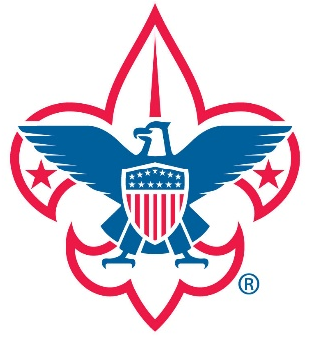
Boy Scout Troop 38
2020-2021
POSITION | SCOUT
SENIOR PATROL LEADER | ZACH H.
ASSISTANT SENIOR PATROL LEADER | COLIN D.
TROOP SCRIBE
QUARTER MASTER | JERIAH B.
*QUARTER MASTER (ASST.) | ALEX S.
LIBRARIAN
HISTORIAN
TROOP GUIDE | ADAM S.
WEBMASTER
BUGLER
*MUSICIAN
DEN CHIEF
CHAPLAIN’S AIDE | SAWYER B.
OUTDOOR ETHICS GUIDE
ORDER OF THE ARROW REP.
PATROL LEADER – COOL AID | PRESTON B.
*ASST. PATROL LEADER | TRISTAN C.
PATROL LEADER – FLYING TOASTERS | DEVON F.
*ASST. PATROL LEADER | JERIAH B.
*Not a Position of Responsibility
Chartered by Dansville Fish and Game
Founded 1924

